User Story, Collaborative User Story Writing and Backlog Refinement Sessions

1-User Story

What is User Story
# Source: Chatgpt (GPT-5-Standard) at [8/17/2025]
A User Story is a short, simple description of a feature or functionality told from the perspective of the end user (or customer) in Agile development.
👉 It answers:
- Who wants the feature?
- What do they want?
- Why do they want it?

🔑 Format (classic template)
# Source: Chatgpt (GPT-5-Standard) at [8/17/2025]
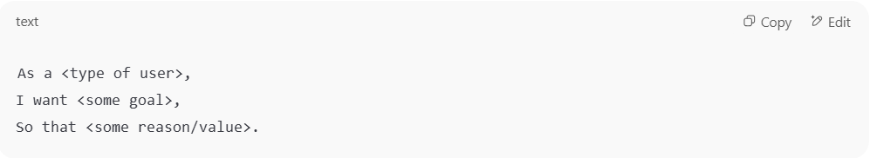
As a <type of user>,
I want <some goal>,
So that <some reason/value>.

✅ Example:
- As a registered user
- I want to reset my password
- So that I can log in again if I forget it

🔎 Characteristics of a Good User Story (INVEST model)
# Source: Chatgpt (GPT-5-Standard) at [8/17/2025]
- Independent – can be developed/tested separately
- Negotiable – details can be discussed/collaborated on
- Valuable – delivers value to the user or customer
- Estimable – can be sized by the team
- Small – fits within a sprint/iteration
- Testable – has clear acceptance criteria

🛠️ What User Stories are NOT
# Source: Chatgpt (GPT-5-Standard) at [8/17/2025]
- They are not full specifications.
- They are not technical tasks.
- They are conversation starters (linked to the 3 C’s: Card, Conversation, Confirmation).

📖 Example with Acceptance Criteria
# Source: Chatgpt (GPT-5-Standard) at [8/17/2025]
User Story:
As a shopper, I want to add items to a wishlist so that I can save them for later purchase.
Acceptance Criteria (Confirmation):
- ✅ Item appears in the wishlist after clicking "Add to Wishlist."
- ✅ Wishlist is saved under the user’s account.
- ✅ User can remove items from the wishlist.

🔹 INVEST Acronym
# Source: Chatgpt (GPT-5-Standard) at [9/13/2025]
INVEST is a checklist used in Agile (especially Scrum and XP) to help ensure that User Stories are well-written and effective.

Each letter stands for a quality that a good User Story should have:
- I – Independent
  - The story should be as self-contained as possible.
  - It shouldn’t depend heavily on another story to deliver value.
  - ✅ Example: “As a user, I can reset my password” (independent).
  - ❌ Bad: “As a user, I can enter my password, if story #12 (signup) is complete.”
- N – Negotiable
  - The story is not a contract.
  - Details can be discussed and refined between the Product Owner and the team.
  - Example: “As a user, I can receive notifications” → team can later decide SMS, email, or push.
- V – Valuable
  - The story must deliver value to the end user or customer.
  - ✅ Good: “As a shopper, I can save items to my wishlist so I can purchase them later.”
  - ❌ Bad: “As a developer, I want to refactor the code.” (this is a task, not user value).
- E – Estimable
  - The team must be able to estimate the effort.
  - If it’s too vague or too big, break it down.
  - Example: “As an admin, I can generate sales reports” (estimable).
- S – Small
  - The story should be small enough to complete within a sprint (usually a few days).
  - If too large, split it into smaller stories.
  - Example: “As a user, I can search for products by name.” (small).
  - Bad: “As a user, I can manage all aspects of my account.” (too big).
- T – Testable
  - There must be clear acceptance criteria so the team can test it.
  - Example: “As a user, I can log in with a valid email and password.”
    - Acceptance test: login succeeds with valid credentials, fails with invalid ones.

✅ In short:
A good User Story should be:
👉 Independent, Negotiable, Valuable, Estimable, Small, Testable.

⚖️ Final Definition
# Source: Chatgpt (GPT-5-Standard) at [8/17/2025]
A User Story is a short, user-centered description of a feature that captures what the user wants, why they want it, and provides a basis for collaborative discussions and acceptance criteria in Agile development.

2-Collaborative User Story Writing

What is Collaborative User Story Writing
# Source: Chatgpt (GPT-5-Standard) at [8/17/2025]
Collaborative User Story Writing is a practice in Agile software development where the whole team (developers, testers, product owners, business analysts, and sometimes customers) works together to create and refine user stories.
👉 Instead of the Product Owner writing stories alone and then handing them off, the team collaborates to:
- Understand the requirement together
- Ask clarifying questions
- Agree on acceptance criteria
- Ensure shared understanding of what to build and test

🔑 Key Characteristics
# Source: Chatgpt (GPT-5-Standard) at [8/17/2025]
- Team activity (not a solo task).
- Encourages communication & shared ownership.
- Stories are co-created, so fewer misunderstandings later.
- Aligns development and testing with business needs.

🛠️ Common Practices
# Source: Chatgpt (GPT-5-Standard) at [8/17/2025]
- Story-writing workshops – scheduled sessions where the team writes/refines multiple stories together.
- Three Amigos technique – a discussion between a business person (what to build), a developer (how to build), and a tester (how to test/validate).
- Acceptance criteria brainstorming – team agrees on “done” conditions.
- Specification by Example (SbE) – creating stories with concrete examples.

📖 Example
# Source: Chatgpt (GPT-5-Standard) at [8/17/2025]
Instead of:
- Product Owner writes:
“As a user, I want to reset my password so I can log in again if I forget it.”
Collaborative session adds clarity:
- Team discusses possible flows:
  - Reset link via email
  - Expiry time of the link
  - Error handling if email not registered
- Agreed acceptance criteria:
  - ✅ Email sent when valid email provided
  - ✅ Link expires after 1 hour
  - ✅ Error shown if email is unknown
Now, the whole team has the same understanding.

✅ Benefits
# Source: Chatgpt (GPT-5-Standard) at [8/17/2025]
- Builds shared understanding of requirements.
- Catches missing details early.
- Ensures stories are testable.
- Reduces rework & miscommunication.
- Encourages collaboration across roles.

🟢 The 3 C’s of User Stories
# Source: Chatgpt (GPT-5-Standard) at [8/17/2025]
The 3 C’s stand for:
- Card 🃏
  - The user story is usually written on a card (physical or digital).
  - The card itself is just a placeholder for a conversation, not the full detail.
  - Example card:
“As a user, I want to reset my password so I can log in if I forget it.”

- Conversation 💬
  - The real value of the story comes from discussions between the Product Owner, developers, testers, and stakeholders.
  - These conversations clarify details, explore options, and resolve ambiguities.
  - It’s during the conversation that the team discovers edge cases, rules, and examples.

- Confirmation ✅
  - The team writes acceptance criteria or tests that confirm when the story is done.
  - These criteria ensure shared understanding and prevent misunderstandings.
  - Example:
    - ✅ A password reset email is sent if the email exists.
    - ✅ The link expires after 1 hour.
    - ✅ Error message shown for unregistered email.

📊 Summary Table
# Source: Chatgpt (GPT-5-Standard) at [8/17/2025]
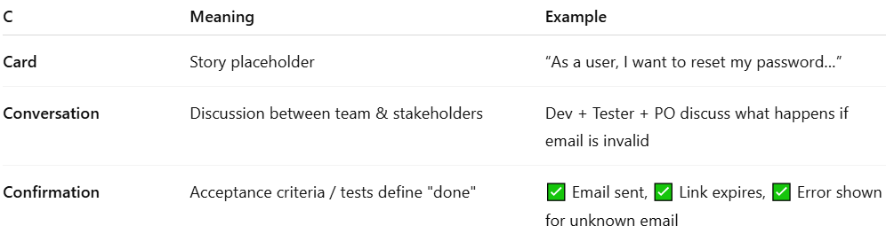
C | Meaning | Example
Card | Story placeholder | “As a user, I want to reset my password…”
Conversation | Discussion between team & stakeholders | Dev + Tester + PO discuss what happens if email is invalid
Confirmation | Acceptance criteria / tests define "done" | ✅ Email sent, ✅ Link expires, ✅ Error shown for unknown email

⚖️ Final Definition
# Source: Chatgpt (GPT-5-Standard) at [8/17/2025]
The 3 C’s (Card, Conversation, Confirmation) describe how user stories are lightweight placeholders that spark collaborative discussion, and result in clear acceptance criteria that confirm when the story is complete.

⚠️ Challenges
# Source: Chatgpt (GPT-5-Standard) at [8/17/2025]
- Needs time and facilitation.
- Can feel slow at first (but saves time later).
- Requires active participation from everyone.

⚖️ Final Definition
# Source: Chatgpt (GPT-5-Standard) at [8/17/2025]
Collaborative User Story Writing = a team-based Agile practice where developers, testers, product owners, and stakeholders work together to create, refine, and agree on user stories and acceptance criteria, ensuring shared understanding and reducing misunderstandings.

3-Backlog Refinement Sessions

What is Backlog Refinement Sessions
# Source: Chatgpt (GPT-5-Standard) at [9/10/2025]
Backlog refinement (sometimes called backlog grooming) sessions are regular team meetings where the team reviews and updates the product backlog to make sure it is:
- Clear (everyone understands each item),
- Prioritized (highest-value work at the top), and
- Ready for upcoming development sprints or iterations.
In other words: It’s when the product owner, developers, testers, and sometimes other stakeholders get together to make sure the list of work (the backlog) is well-prepared for the future.

🔹 Purpose of Backlog Refinement
# Source: Chatgpt (GPT-5-Standard) at [9/10/2025]
- Break down large items (epics) into smaller, testable user stories.
- Clarify requirements and acceptance criteria.
- Estimate effort (e.g., story points, time).
- Reprioritize based on business needs or technical dependencies.
- Remove outdated or irrelevant items.

🔹 Who Attends
# Source: Chatgpt (GPT-5-Standard) at [9/10/2025]
- Product Owner → brings the business priorities and context.
- Developers → give technical insights and estimates.
- QA / Testers → help define testable acceptance criteria and spot risks early.
- Sometimes UX, business analysts, or other roles join if needed.

🔹 When It Happens
# Source: Chatgpt (GPT-5-Standard) at [9/10/2025]
- Typically once or twice per sprint in Agile teams.
- Not a formal Scrum event but a best practice to keep the backlog healthy.

🔹 Example
# Source: Chatgpt (GPT-5-Standard) at [9/10/2025]
In a banking app project:
- The product owner brings a new item: “As a user, I want to reset my password.”
- In the refinement session, the team:
  - Discusses the feature, identifies missing details (e.g., via email or SMS?).
  - Splits into smaller stories (e.g., UI for reset, backend for token, email sending).
  - Defines acceptance criteria (e.g., token expires after 10 min).
  - Estimates the effort.
  - Marks it as “Ready for Development.”

💡 Key takeaway:
# Source: Chatgpt (GPT-5-Standard) at [9/10/2025]
Backlog refinement sessions are about preparing the upcoming work so the team can develop smoothly without confusion or last-minute clarification.

🧪 Tester’s Role in Backlog Refinement Sessions
# Source: Chatgpt (GPT-5-Standard) at [9/10/2025]
1. Ensure user stories are testable
Testers check that each backlog item (user story, epic, bug, etc.):
- Has clear acceptance criteria (conditions of satisfaction).
- Avoids ambiguity (no “maybe,” “should,” or unclear words).
- Can be validated objectively — meaning there’s a clear “pass” or “fail.”

2. Ask “what if” questions
They bring the “what can go wrong?” mindset:
- What happens if the network fails?
- How does this behave with invalid input?
- Are there performance or security concerns?
This helps uncover hidden requirements or missing scenarios.

3. Highlight risks
QA can flag high-risk areas early:
- Complex logic
- Dependencies on third-party systems
- Features with high user impact
This allows the team to prioritize testing and sometimes change design before coding starts.

4. Suggest test data and environment needs
During refinement, testers can:
- Identify special test data required (e.g., edge cases, boundary values).
- Check if new tools or environments will be needed.
- Plan for automation or performance testing early.

5. Assist with estimation
QA gives input on testing effort:
- Manual test coverage complexity
- Automation feasibility
- Extra checks (like compliance, accessibility, or localization)
This helps the team give more realistic story estimates.

6. Promote shared understanding
By discussing acceptance criteria and potential tests openly, testers help:
- Developers, product owners, and others see the feature the same way.
- Reduce misunderstandings that lead to defects later.

💡 Summary:
During backlog refinement, testers act like quality advisors — ensuring backlog items are clear, testable, risk-aware, and feasible before they ever reach development. This supports the whole-team approach to building quality in from the start.

🏦 Real Example — Backlog Item Before and After Refinement (with Tester Contributions)
# Source: Chatgpt (GPT-5-Standard) at [9/10/2025]
📝 Initial User Story (before refinement)
“As a banking app user, I want to reset my password.”
That’s it — very high level, vague, not yet ready for development or testing.

🧑‍💻 Refinement Session
Discussion
- Product Owner: It’s for users who forgot their password.
- Developer: Will we use email or SMS?
- Tester: What happens if the token expires? What if the user enters the wrong token multiple times?
- Tester: We need to define how secure the reset flow is (e.g., lock account after too many attempts).
- Tester: Are there legal/compliance rules (like GDPR) about sending reset links?
- Developer: Should we prevent reuse of old passwords?

🧪 Tester’s Contributions
- Ensured testable acceptance criteria: the team writes clear conditions to verify.
- Identified edge cases: wrong token, expired token, multiple failed attempts.
- Highlighted security risks early.
- Planned test data: valid/invalid emails, existing/non-existing users.
- Gave estimation input for manual + automated tests.

📋 User Story After Refinement (ready for sprint)
User Story:
As a banking app user, I want to reset my password by receiving a secure token via email so that I can regain access to my account safely.
Acceptance Criteria:
- User enters their registered email address.
- A one-time token link is sent to that email, valid for 10 minutes.
- Clicking the link opens a secure reset page.
- User must enter a new password meeting complexity rules.
- If the token is invalid, expired, or already used → display “Invalid or expired link.”
- After 3 failed attempts, the account is locked for 30 minutes.
- User cannot reuse the last 3 passwords.
Notes from testers:
- Edge cases: wrong email, unregistered email, expired token.
- Negative testing: multiple failed attempts, SQL injection in reset form, cross-site scripting checks.
- Test data: accounts with locked status, test accounts without emails.

💡 Result:
The story is now clear, testable, risk-aware, and feasible. Developers know what to build, and testers know exactly what to test — thanks to everyone, including QA, collaborating in refinement.

